Tile Builder

Multi Attribute Monitor

Version 1.0

Revised 7/15/23

# Table of Contents

Table of Contents 2

Creating a Tile Using Multi Attribute Monitor 3

Customizing Display Options 3

Simple Format Rules 4

Advanced Format Rules 6

Progress Bar Example 6

Meter Example 6

# Creating a Tile Using Multi Attribute Monitor

Within the **Tile Builder** parent app go to the section called **Create Tile** and select **Add New Multi Attribute Monitor**. The **Multi Attribute Monitor** main screen will be displayed. To begin with you must select the number of **Devices\Attributes** the table will display. In the example below I selected 6.

Now select the first device, name it using the Item Name column and select the attribute to be displayed. My line looks like this.



And the table looks like this.

## Customizing Display Options

**Item Name:** The text in this field will be displayed in the **Device** column. You can use HTML tags like **[b]Bedroom Temp[/b]** to make the text bold as an example.

**Prepend:** You can prepend the attribute value with any text you choose. For example **[b]** would make the value bold. Note that a closing **[/b]** is not required for it to display properly but I usually provide one unless I’m short of space.

**Append:** You can append any text to the attribute value. Units will be common such as °F or lux or kWh.

**Cleanup:** These are special operations that can be used to “clean up” the data. Currently available options are:

1. Capitalize: Makes the first letter a capital
2. Commas: Adds a comma format to large numbers, 64894 would become 64,896.
3. 0 Decimal Places: Sets number of decimal places for floats, 78.54 would become 78.
4. 1 Decimal Places: Sets number of decimal places for floats, 78.54 would become 78.5.
5. Upper Case: Sets all alpha characters to uppercase, ‘off’ would become ‘OFF’.
6. Apply Format Rule X: See upcoming section of Format rules.

The screenshot below shows the first 5 of these cleanup options in use to create a more attractive table. Other than embedding HTML tags this interface is straightforward. In the next section we cover the use of Format Rules, a new concept for the Multi-Attribute Monitor.

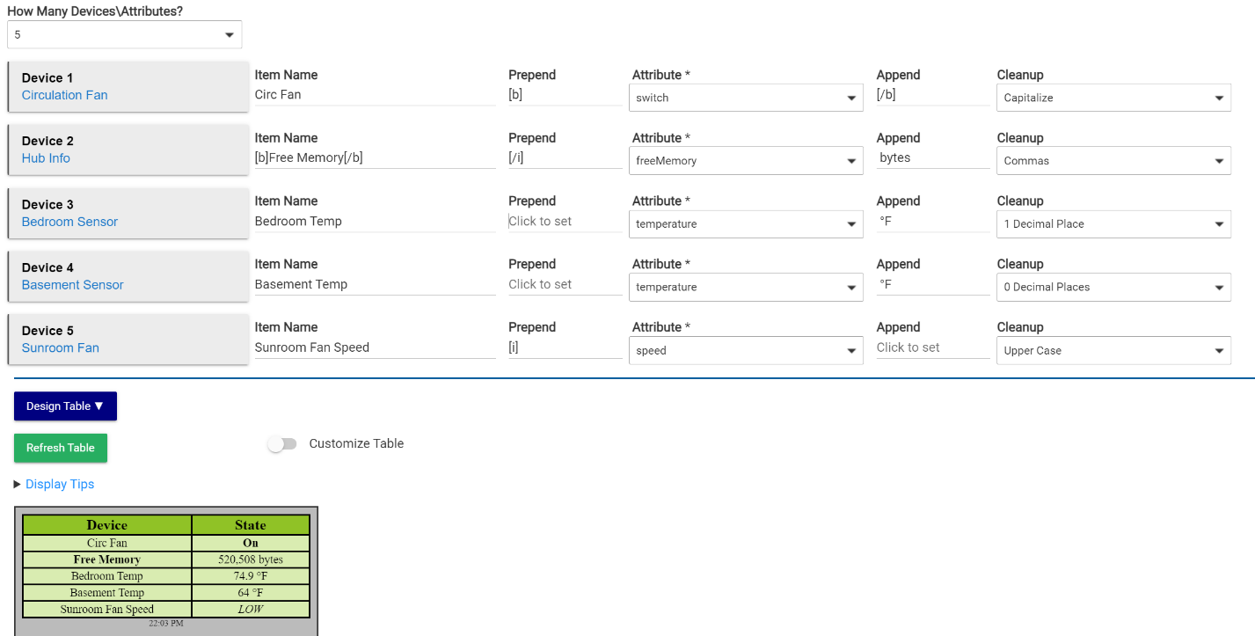

## Simple Format Rules

Format Rules are new in the Multi-Attribute Monitor. In regular Attribute monitor all numeric values are of the same type of unit, temperature for example. In Multi-Attribute Monitor a value of 30 might represent a very comfortable humidity, a low temperature or a failing battery. We therefore cannot use Threshold rules to color code values in the same way that we might do in Attribute Monitor.

|  |  |
| --- | --- |
| **Threshold Rules to color code Temperatures** | **Result**    Humidity gets color coded as if it were a temperature. |

|  |  |
| --- | --- |
| **Change the cleanup property to Apply Format Rule 1** | **Change Format Rule 1 to %value%** |

The table now displays without the Humidity being processed and color coded by the Highlights.

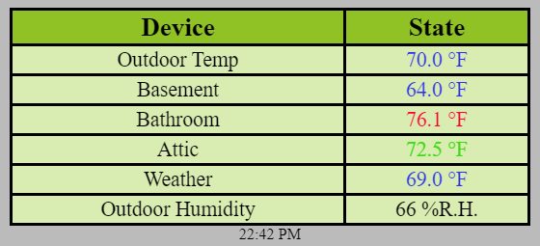

An important aspect of MAM to consider is that the order of the cells is static. We can therefore apply formatting to a particular cell, knowing it will remain consistent and not be sorted or filtered as device values change.

The following example uses an override called **Highlight a table cell with color** in the **Cell Operations** category available in **Tile Builder Advanced**.

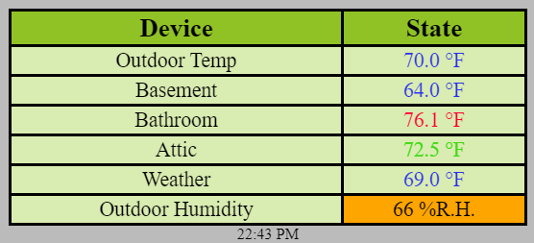

## Advanced Format Rules

In Format Rules you can use the %value% macro to use the dynamic data value. By embedding this %value% in an HTML control we can create simple meters and progress bars.

### Progress Bar Example

To use a value within a progress bar you can use this string and change values as necessary.

%value%%[br][progress value=%value% max=100][/progress]

A data value of 48 would look like this within the table. The [br] adds the line break between the 48% and the progress bar visual.

Display of the progress bar might vary depending on your browser.

### Meter Example

To use a value within a meter you can use this string and adjust as necessary.

%value%%[br][meter low=50 high=80 max=100 optimum=100 value=%value%][/meter]

A value of 75 would look like this. In the above configuration <50 will display in red, 50-79 will display in yellow and 80 and above will display in green.

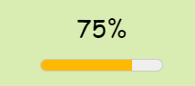

You can find these strings within the app by expanding the Highlight Notes section as shown below. Here you can also reference the degree symbol, which is otherwise tricky with the keyboard.

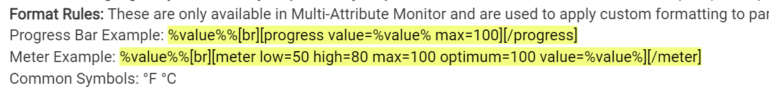

## HTML Compression

Given the 1,024 byte limit for content in the dashboard the amount of space consumed is an important consideration. Multi-Attribute Monitor introduces improved compression of the HTML content.

In the standard version the compression is the same as it is in prior Tile Builder modules with the addition of color compression. MAM now uses the smallest encoding of color available for any given value. All colors in MAM are now either 3,6 or 8 byte HEX values. RGBA is no longer supported.

In Tile Builder Advanced you will find two other options under the Advanced Tab as shown below.

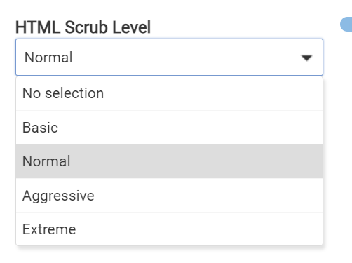

The space savings using Aggressive or Extreme can be quite significant. In the table below the left example is using the “Normal” (default) level of compression and is 988 bytes. The one on the right looks identical except for the values, but is only 812 bytes.

|  |  |
| --- | --- |
|  |  |

**Which level should you use?** If you don’t care about getting the size under 1,024 then just leave it on normal. If you want to get under 1,024 then use the lowest level that meets your goal. The only way to know for sure is to try it but this has worked very well on recent versions of Chrome.

**Why not have it on extreme all the time?** The simple answer is that this level of compression uses techniques that would be considered bad practice, such as not closing certain HTML tags.

The only way to tell if a level will work for you is to try it!